MY CONDITIONS FOR THIS STRATEGY THAT'S.

Bullish Market.
1. THE MARKET MUST BE ABOVE THE 50 EMA.
2. THREE TESTS OF A SUPPORT LEVEL, at that point if we are still above the 50 EMA my conditions are met.
3.MY ENTRY reason is A GREEN CANDLE and the conditions of that green candle is that it must close above the 50 ema.

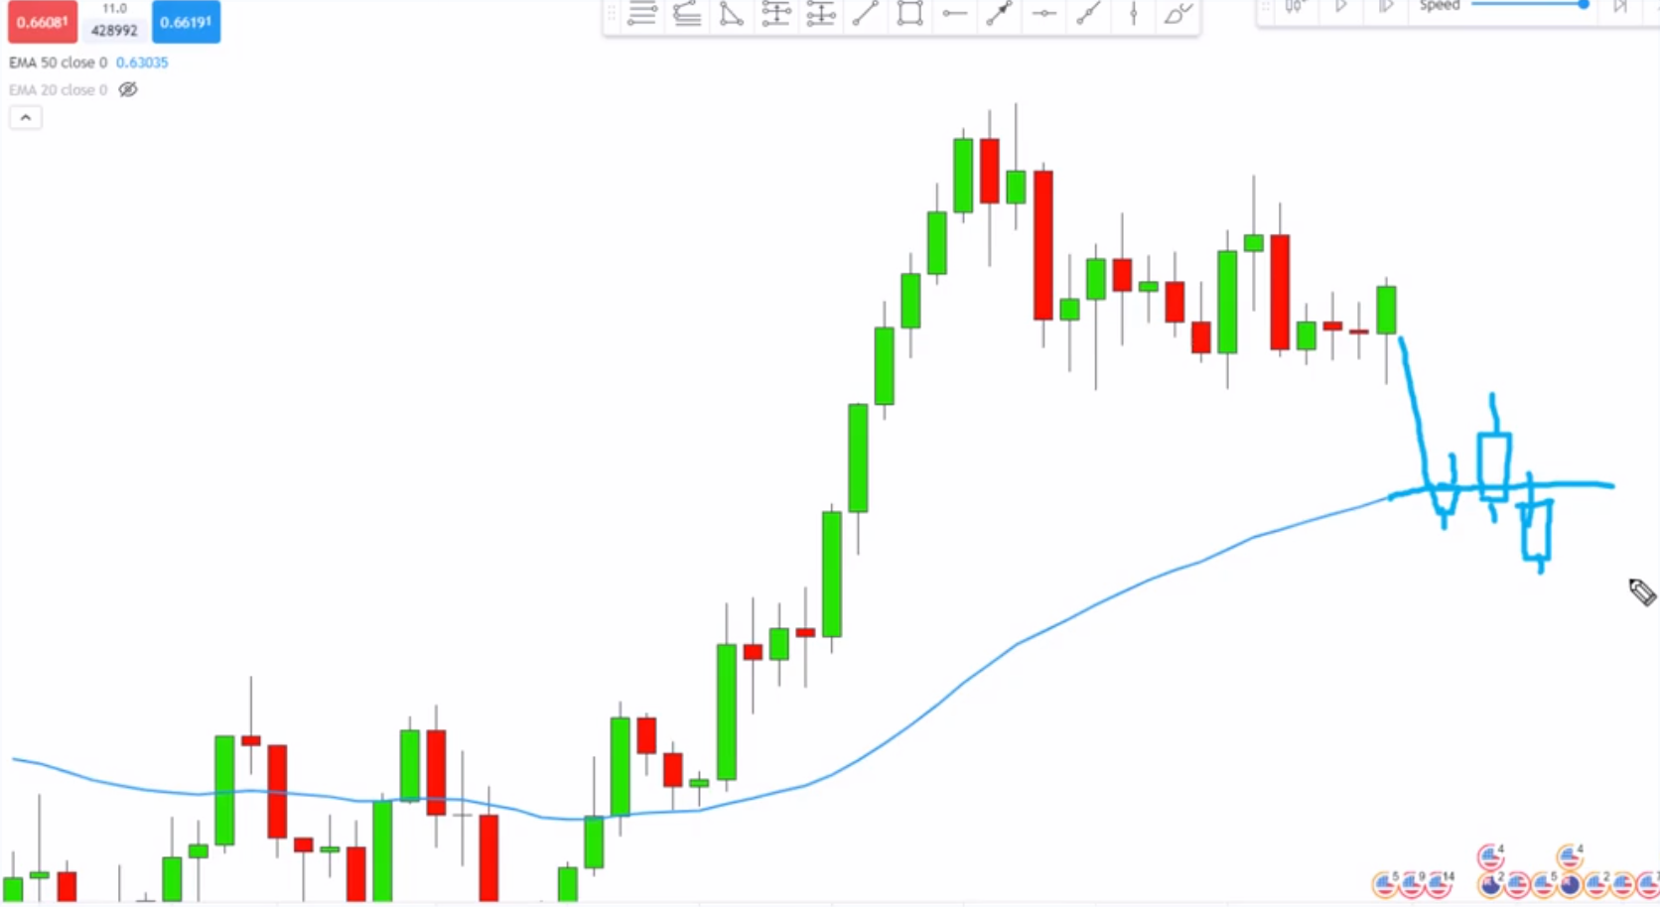
Here candles still touching the 50 EMA with wicks or body it’s still valid.

But when we get a candle that does not touch the 50 EMA, it’s time to discount that trade and start looking for another trade.

Bearish Market example.
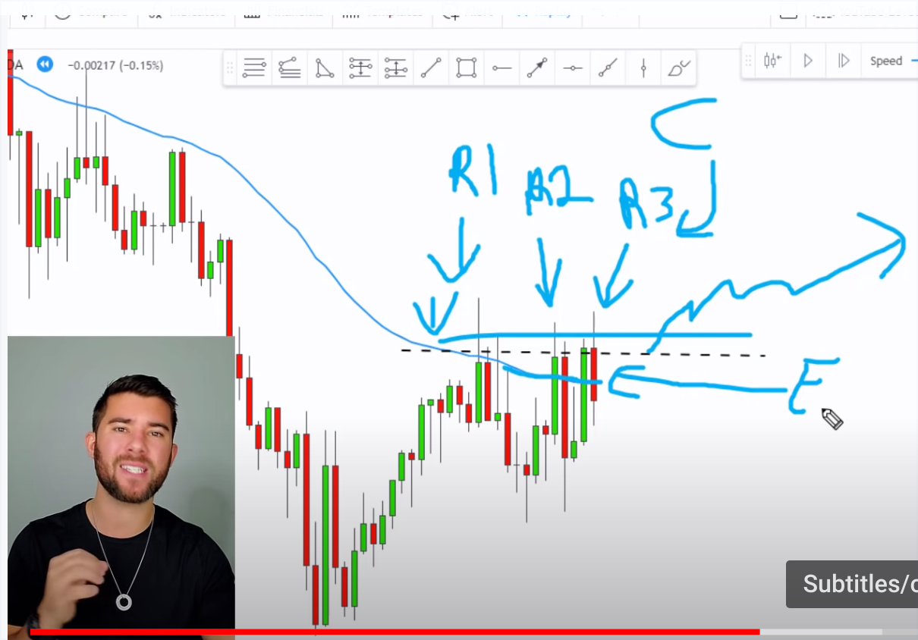
OUR ENTRY is a red candle.
Bearish candle must close below the 50
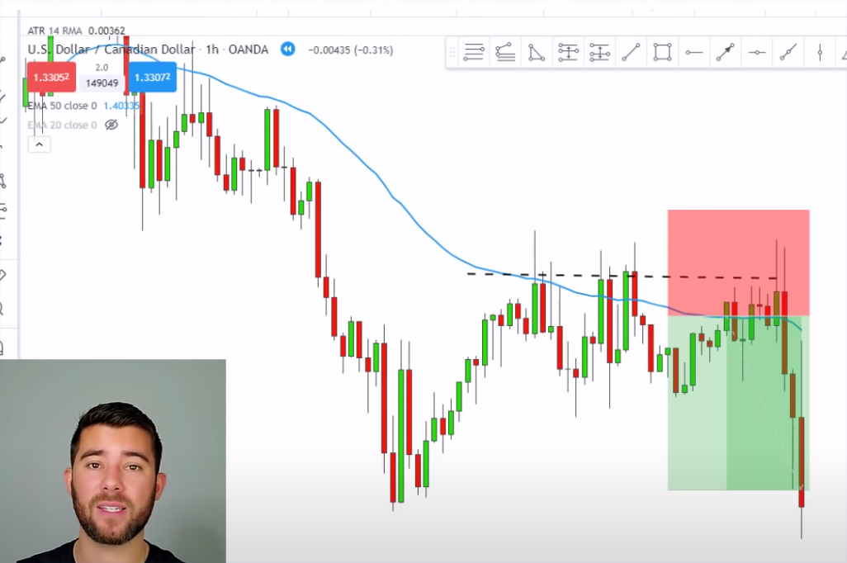
EMA.

